**Codigo Escalera Proyecto Final**



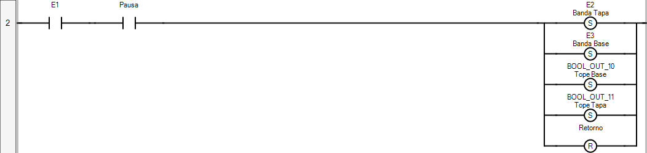

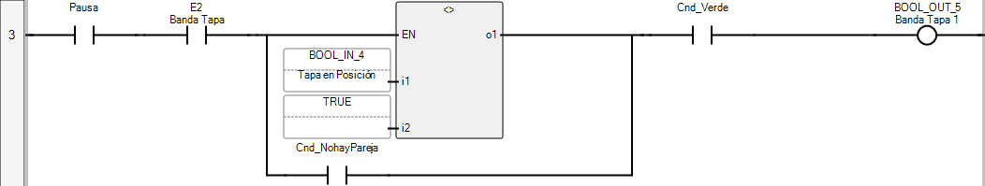

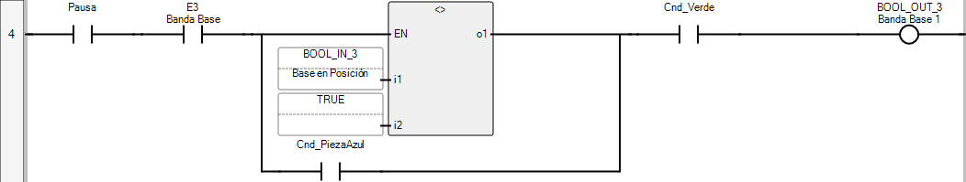







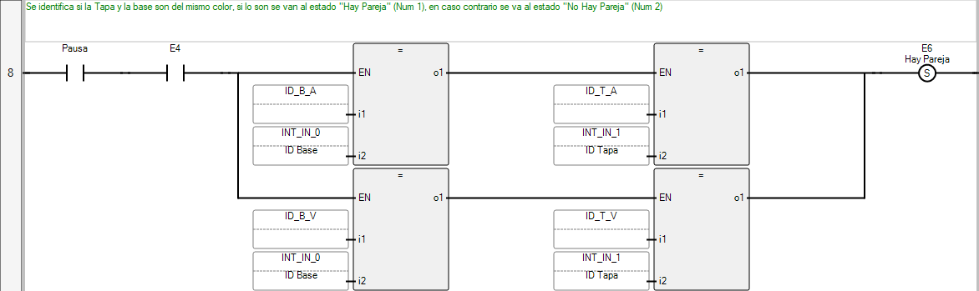

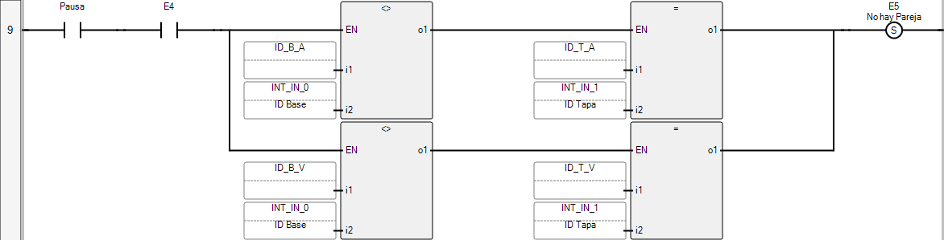

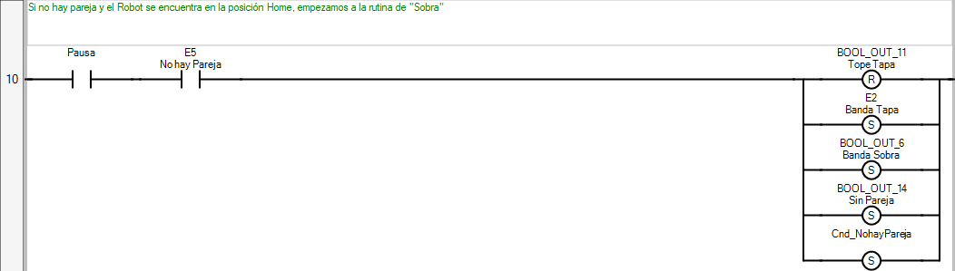

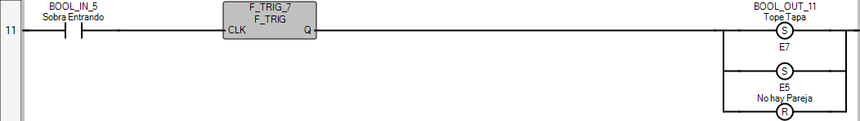

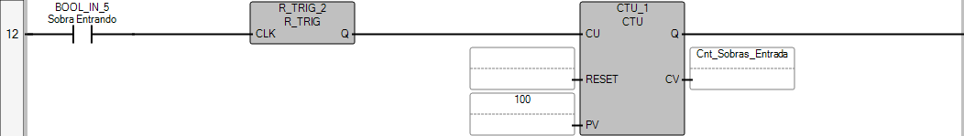

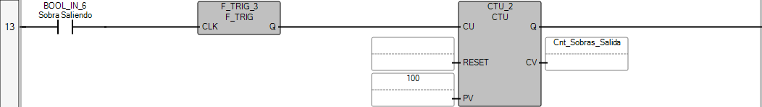

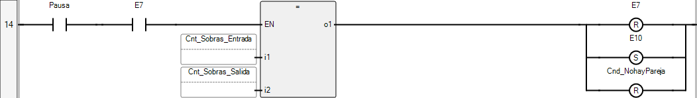

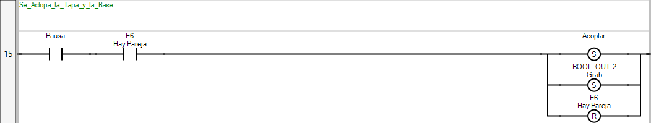









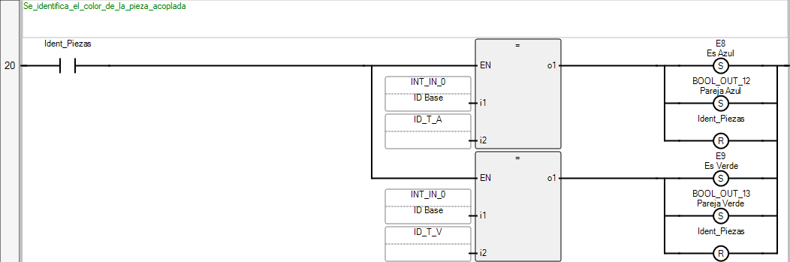

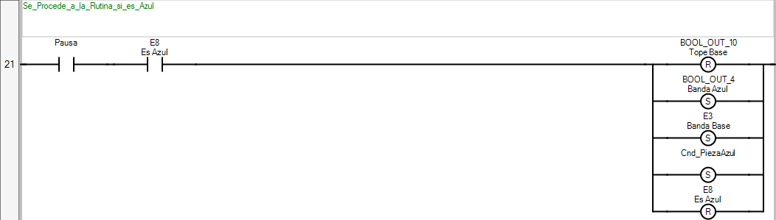





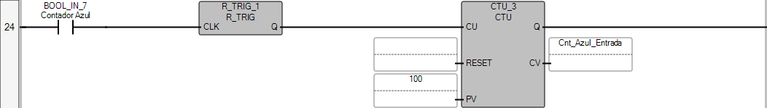

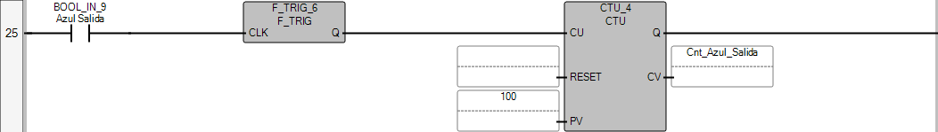

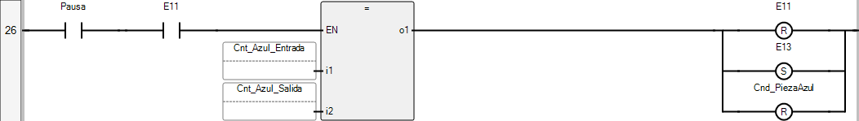

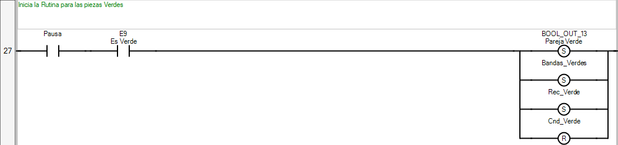

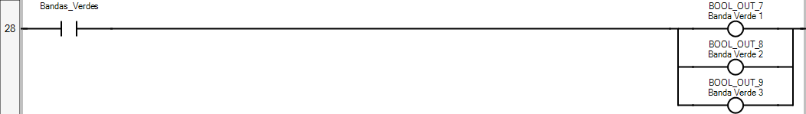

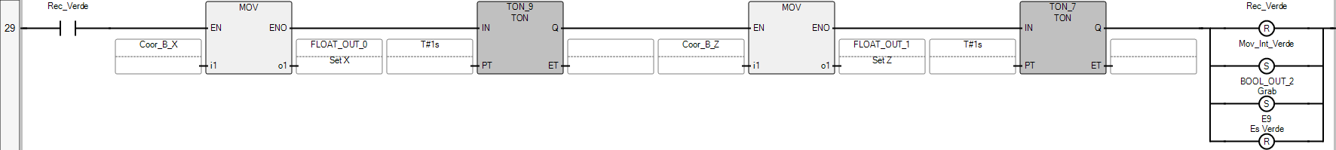



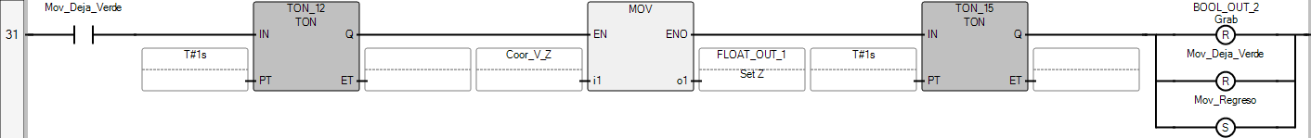



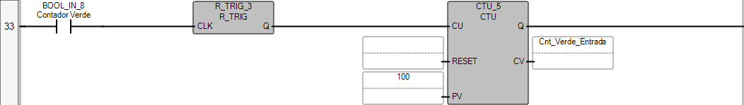

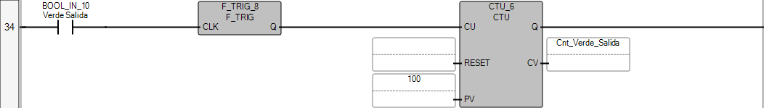

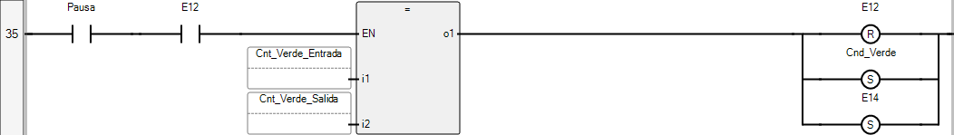

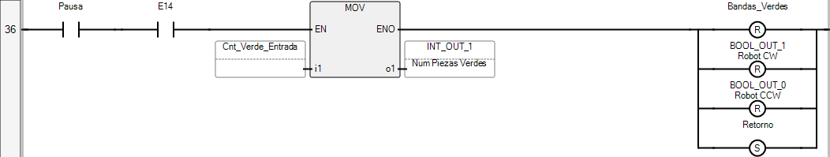



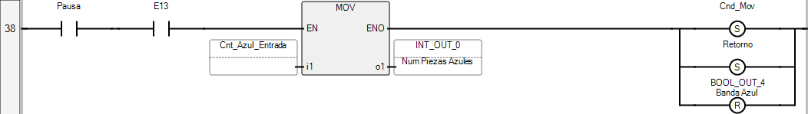



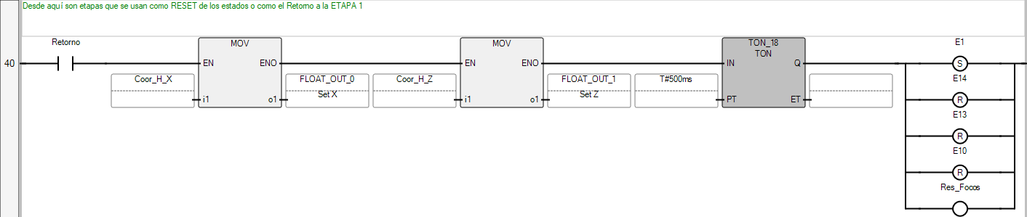

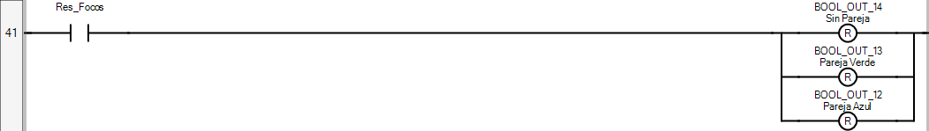



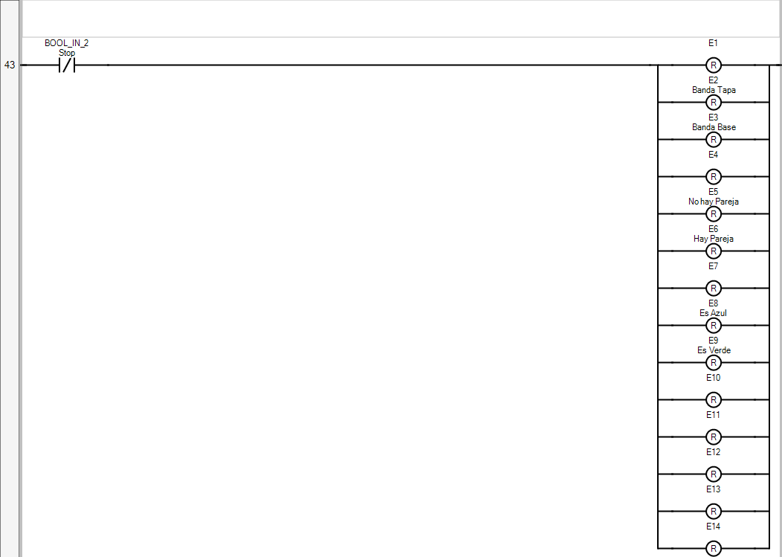

**POU Proyecto Final**

The POU defines 84 variable(s).

**Variable E1**

(* *)

Direction: Var

Data type: BOOL

Attribute: Read/Write

**Variable E2**

(* *)

Direction: Var

Alias: Banda Tapa

Data type: BOOL

Attribute: Read/Write

**Variable E3**

(* *)

Direction: Var

Alias: Banda Base

Data type: BOOL

Attribute: Read/Write

**Variable E4**

(* *)

Direction: Var

Data type: BOOL

Attribute: Read/Write

**Variable E5**

(* *)

Direction: Var

Alias: No hay Pareja

Data type: BOOL

Attribute: Read/Write

**Variable E6**

(* *)

Direction: Var

Alias: Hay Pareja

Data type: BOOL

Attribute: Read/Write

**Variable E7**

(* *)

Direction: Var

Data type: BOOL

Attribute: Read/Write

**Variable E8**

(* *)

Direction: Var

Alias: Es Azul

Data type: BOOL

Attribute: Read/Write

**Variable E9**

(* *)

Direction: Var

Alias: Es Verde

Data type: BOOL

Attribute: Read/Write

**Variable E10**

(* *)

Direction: Var

Data type: BOOL

Attribute: Read/Write

**Variable E11**

(* *)

Direction: Var

Data type: BOOL

Attribute: Read/Write

**Variable E12**

(* *)

Direction: Var

Data type: BOOL

Attribute: Read/Write

**Variable E13**

(* *)

Direction: Var

Data type: BOOL

Attribute: Read/Write

**Variable E14**

(* *)

Direction: Var

Data type: BOOL

Attribute: Read/Write

**Variable Coor_T_X**

(* *)

Direction: Var

Data type: REAL

Attribute: Read/Write

**Variable Coor_T_Z**

(* *)

Direction: Var

Data type: REAL

Attribute: Read/Write

**Variable Coor_B_X**

(* *)

Direction: Var

Data type: REAL

Attribute: Read/Write

**Variable Coor_B_Z**

(* *)

Direction: Var

Data type: REAL

Attribute: Read/Write

**Variable Coor_I_X**

(* *)

Direction: Var

Data type: REAL

Attribute: Read/Write

**Variable Coor_I_Z**

(* *)

Direction: Var

Data type: REAL

Attribute: Read/Write

**Variable Coor_H_X**

(* *)

Direction: Var

Data type: REAL

Attribute: Read/Write

**Variable Coor_H_Z**

(* *)

Direction: Var

Data type: REAL

Attribute: Read/Write

**Variable Coor_V_X**

(* *)

Direction: Var

Data type: REAL

Attribute: Read/Write

**Variable Coor_V_Z**

(* *)

Direction: Var

Data type: REAL

Attribute: Read/Write

**Variable ID_T_A**

(* *)

Direction: Var

Data type: INT

Attribute: Read/Write

**Variable ID_T_V**

(* *)

Direction: Var

Data type: INT

Attribute: Read/Write

**Variable ID_B_A**

(* *)

Direction: Var

Data type: INT

Attribute: Read/Write

**Variable ID_B_V**

(* *)

Direction: Var

Data type: INT

Attribute: Read/Write

**Variable Cnt_Sobras_Salida**

(* *)

Direction: Var

Data type: DINT

Attribute: Read/Write

**Variable Cnt_Sobras_Entrada**

(* *)

Direction: Var

Data type: DINT

Attribute: Read/Write

**Variable Cnt_Azul_Entrada**

(* *)

Direction: Var

Data type: DINT

Attribute: Read/Write

**Variable Cnt_Azul_Salida**

(* *)

Direction: Var

Data type: DINT

Attribute: Read/Write

**Variable Cnt_Verde_Entrada**

(* *)

Direction: Var

Data type: DINT

Attribute: Read/Write

**Variable Cnt_Verde_Salida**

(* *)

Direction: Var

Data type: DINT

Attribute: Read/Write

**Variable Retorno**

(* *)

Direction: Var

Data type: BOOL

Attribute: Read/Write

**Variable Acoplar**

(* *)

Direction: Var

Data type: BOOL

Attribute: Read/Write

**Variable Mov_Int**

(* *)

Direction: Var

Data type: BOOL

Attribute: Read/Write

**Variable Mov_Base**

(* *)

Direction: Var

Data type: BOOL

Attribute: Read/Write

**Variable Mov_Espera**

(* *)

Direction: Var

Data type: BOOL

Attribute: Read/Write

**Variable Ident_Piezas**

(* *)

Direction: Var

Data type: BOOL

Attribute: Read/Write

**Variable Res_Focos**

(* *)

Direction: Var

Data type: BOOL

Attribute: Read/Write

**Variable Rec_Verde**

(* *)

Direction: Var

Data type: BOOL

Attribute: Read/Write

**Variable Mov_Int_Verde**

(* *)

Direction: Var

Data type: BOOL

Attribute: Read/Write

**Variable Mov_Deja_Verde**

(* *)

Direction: Var

Data type: BOOL

Attribute: Read/Write

**Variable Bandas_Verdes**

(* *)

Direction: Var

Data type: BOOL

Attribute: Read/Write

**Variable Cnd_NohayPareja**

(* *)

Direction: Var

Data type: BOOL

Attribute: Read/Write

**Variable Cnd_PiezaAzul**

(* *)

Direction: Var

Data type: BOOL

Attribute: Read/Write

**Variable Cnd_PiezaVerde**

(* *)

Direction: Var

Data type: BOOL

Attribute: Read/Write

**Variable TON_8**

(* *)

Direction: Var

Data type: TON

Attribute: Read/Write

**Variable TON_6**

(* *)

Direction: Var

Data type: TON

Attribute: Read/Write

**Variable TON_5**

(* *)

Direction: Var

Data type: TON

Attribute: Read/Write

**Variable TON_4**

(* *)

Direction: Var

Data type: TON

Attribute: Read/Write

**Variable TON_3**

(* *)

Direction: Var

Data type: TON

Attribute: Read/Write

**Variable TON_1**

(* *)

Direction: Var

Data type: TON

Attribute: Read/Write

**Variable TON_2**

(* *)

Direction: Var

Data type: TON

Attribute: Read/Write

**Variable CTU_2**

(* *)

Direction: Var

Data type: CTU

Attribute: Read/Write

**Variable F_TRIG_3**

(* *)

Direction: Var

Data type: F_TRIG

Attribute: Read/Write

**Variable CTU_1**

(* *)

Direction: Var

Data type: CTU

Attribute: Read/Write

**Variable R_TRIG_2**

(* *)

Direction: Var

Data type: R_TRIG

Attribute: Read/Write

**Variable F_TRIG_7**

(* *)

Direction: Var

Data type: F_TRIG

Attribute: Read/Write

**Variable TON_9**

(* *)

Direction: Var

Data type: TON

Attribute: Read/Write

**Variable TON_7**

(* *)

Direction: Var

Data type: TON

Attribute: Read/Write

**Variable TON_11**

(* *)

Direction: Var

Data type: TON

Attribute: Read/Write

**Variable TON_10**

(* *)

Direction: Var

Data type: TON

Attribute: Read/Write

**Variable TON_15**

(* *)

Direction: Var

Data type: TON

Attribute: Read/Write

**Variable R_TRIG_3**

(* *)

Direction: Var

Data type: R_TRIG

Attribute: Read/Write

**Variable CTU_5**

(* *)

Direction: Var

Data type: CTU

Attribute: Read/Write

**Variable F_TRIG_8**

(* *)

Direction: Var

Data type: F_TRIG

Attribute: Read/Write

**Variable CTU_6**

(* *)

Direction: Var

Data type: CTU

Attribute: Read/Write

**Variable TON_12**

(* *)

Direction: Var

Data type: TON

Attribute: Read/Write

**Variable TON_16**

(* *)

Direction: Var

Data type: TON

Attribute: Read/Write

**Variable TON_14**

(* *)

Direction: Var

Data type: TON

Attribute: Read/Write

**Variable Cnd_Verde**

(* *)

Direction: Var

Data type: BOOL

Attribute: Read/Write

**Variable TON_17**

(* *)

Direction: Var

Data type: TON

Attribute: Read/Write

**Variable CTU_4**

(* *)

Direction: Var

Data type: CTU

Attribute: Read/Write

**Variable F_TRIG_6**

(* *)

Direction: Var

Data type: F_TRIG

Attribute: Read/Write

**Variable CTU_3**

(* *)

Direction: Var

Data type: CTU

Attribute: Read/Write

**Variable R_TRIG_1**

(* *)

Direction: Var

Data type: R_TRIG

Attribute: Read/Write

**Variable R_TRIG_4**

(* *)

Direction: Var

Data type: R_TRIG

Attribute: Read/Write

**Variable F_TRIG_1**

(* *)

Direction: Var

Data type: F_TRIG

Attribute: Read/Write

**Variable Mov_Regreso**

(* *)

Direction: Var

Data type: BOOL

Attribute: Read/Write

**Variable TON_18**

(* *)

Direction: Var

Data type: TON

Attribute: Read/Write

**Variable Pausa**

(* *)

Direction: Var

Data type: BOOL

Attribute: Read/Write